Item | Description
Document Title | How to Create App Registration on Azure For SSO
Document Owner | Ritesh Patidar
Document Classification | Internal Doc

Document Details
Document Revision Record (Change History - Created / Modified/Reviewed)
Version | Change History | Name (by) | Date | Remarks
1.0 | Created | Ritesh Patidar | 04/07/2025 | Initial Version
1.2 | Updated | Ritesh Patidar | 10-12-2025 | Remove Role and Group Creation and Assign Part

This guide walks through creating two app registrations:
Step 1: Click on Entra ID
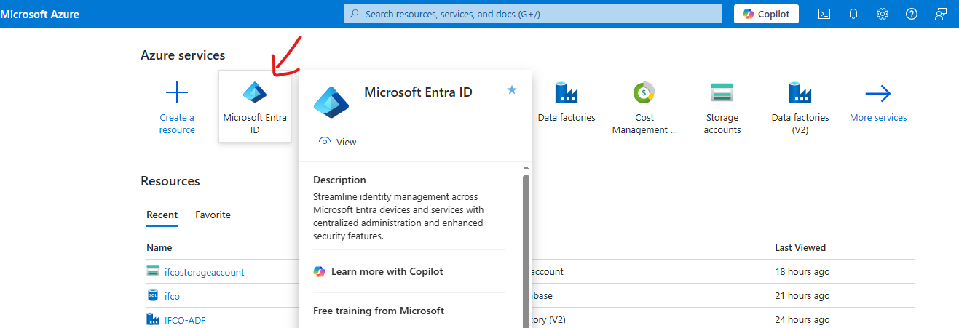
Step 2: Register the SPA App (IFCO-UI)
2.1 Go to Azure AD App Registrations
- Navigate to Azure Active Directory > App registrations
- Click + New registration

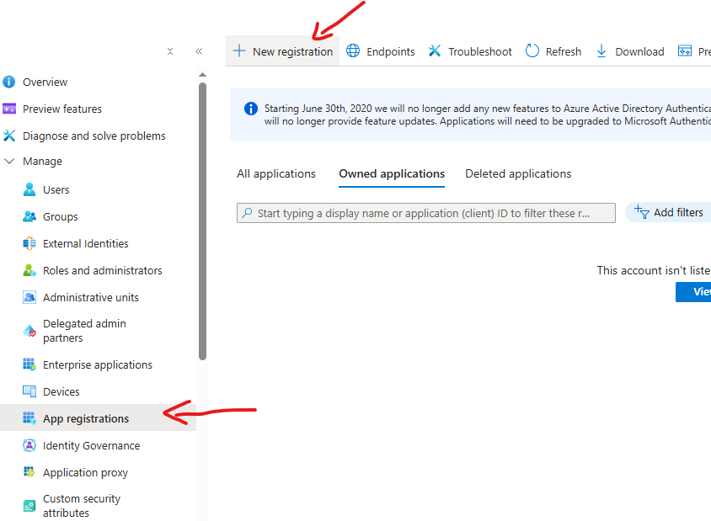
2.2 App Registration Settings
- Name: IFCO-UI
- Supported account types: Choose based on need:
  - Accounts in this organizational directory only (for single tenant)
Select a Platform: Single-page application (SPA)
Redirect URI : Enter a URI

- add all client URIs or UI Service IFCO application Domain Name
For example : https://localhost:3000
https://your-production-url.com

2.3 Click Register
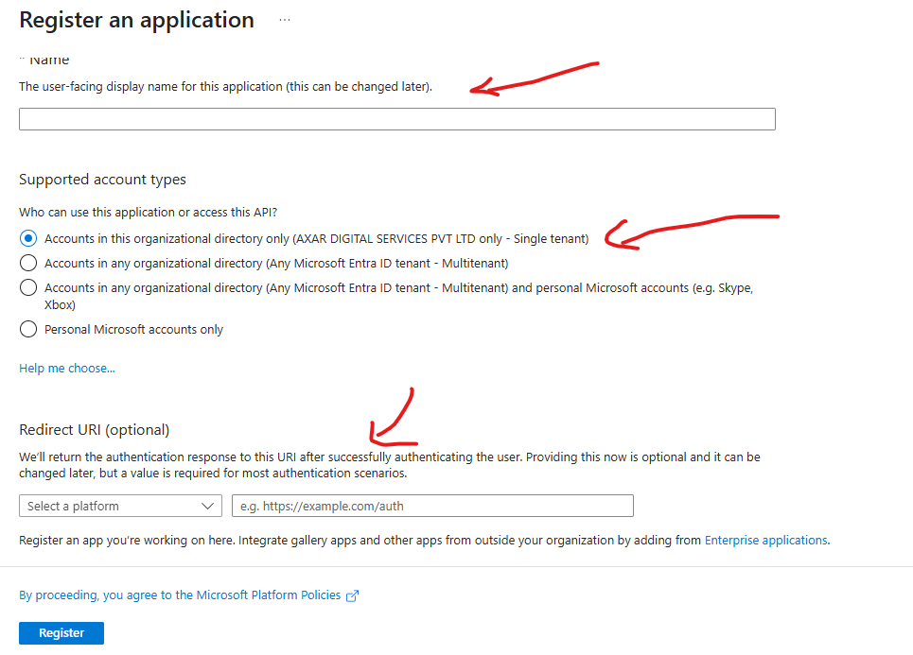

Step 3: Configure IFCO-UI
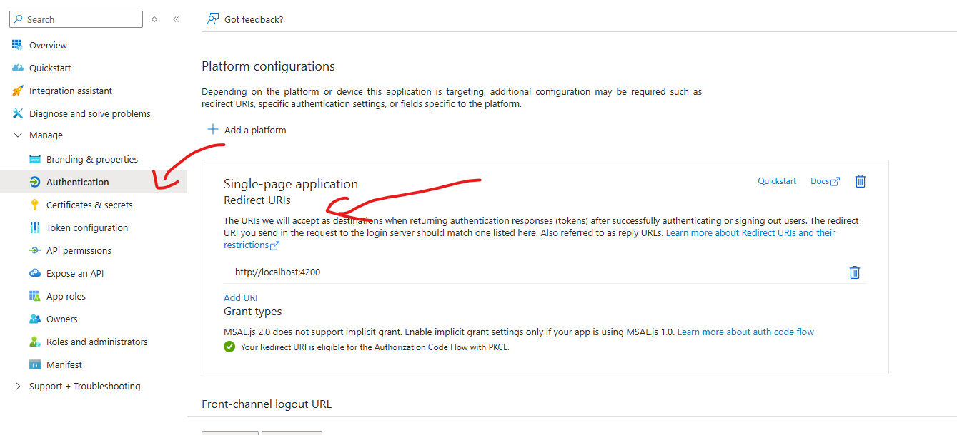
3.1 Add Redirect URIs
- Go to the IFCO-UI app > Authentication
- Under Redirect URIs, add all client URIs or UI Service IFCO application Domain Name
For example : https://localhost:3000
https://your-production-url.com
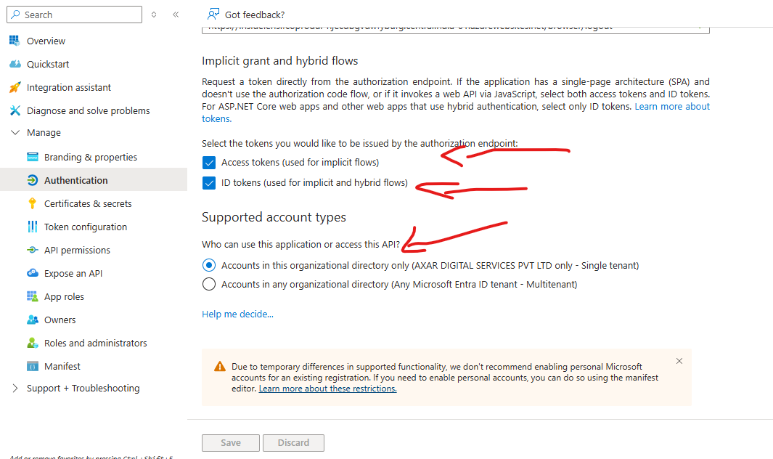
3.2 Enable Access Tokens
- Under Implicit grant and hybrid flows, check:
  - Access tokens
  - ID tokens
- Click Save

Step 4: IFCO-UI App Register is Completed
4.1 Go to overview
- Copy the Application (client) ID value
- Copy the Application Directory (tenant) ID value
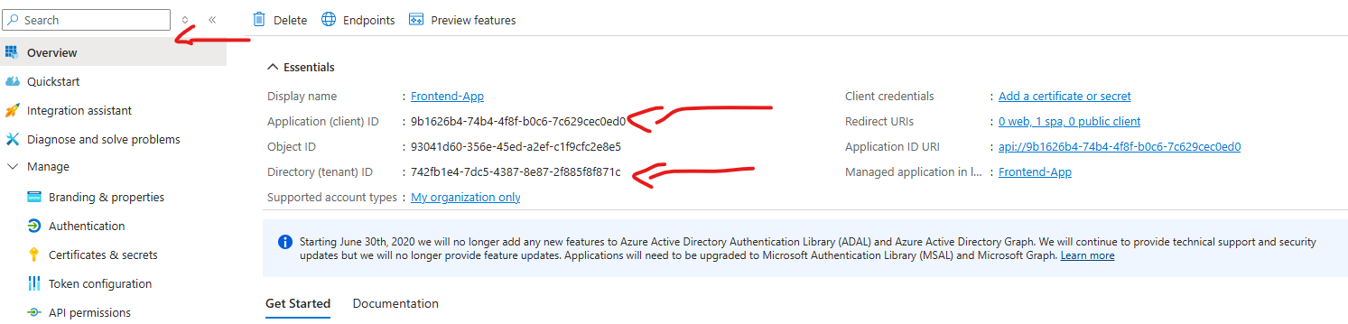

Step 5: Register the Web App (IFCO-Server)
5.1 Go to App Registrations
- Go back to App registrations > + New registration


5.2 App Registration Settings
- Name: IFCO-Server
- Supported account types: Choose your tenant needs
- Select a Platform: Web
- Redirect URI : add server URIs or API Service IFCO application Domain Name
For example: https://localhost:9000
https://your-production-url.com
- 
5.3 Click Register

Step 6: Configure IFCO-Server
6.1 Expose API
- Go to IFCO-Server > Expose an API
- Click Set under "Application ID URI" (e.g., api://{client-id} or a custom URI)
- Click + Add a scope
  - Scope name: access_as_user
  - Who can consent : admin and users
  - Admin consent display name: Access IFCO-Server
  - Admin consent description: Allow the app to access IFCO-Server on behalf of the user
  - State: Enabled
- Click Add scope
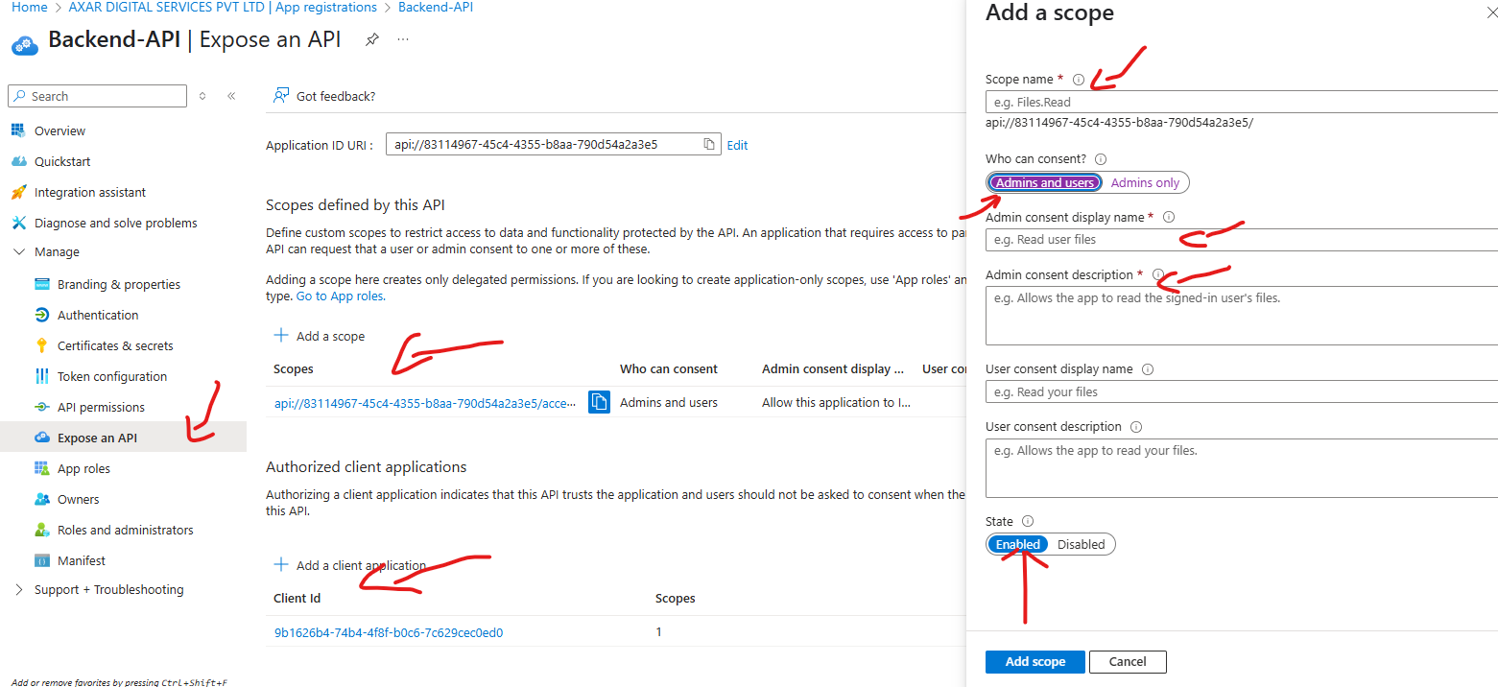

6.2 Define Permissions a client application(IFCO-UI)
- Now copy the Client ID from the (IFCO-UI ) app registration

- Go back to the ‘Expose an API’ tab of IFCO-Server API app registration and click on ‘’. Paste the Client ID into the field ‘Client ID’.
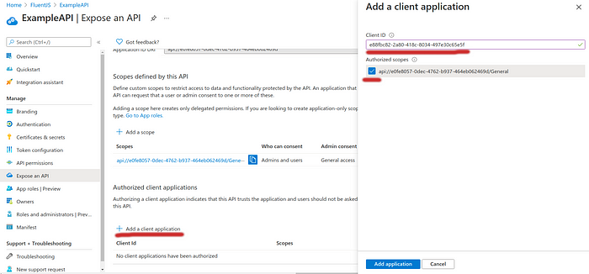

- Add (IFCO-UI)app as a client application to (IFCO-Server) API
6.3 Define Permissions for SPA
- Go to IFCO-UI > API permissions > + Add a permission
  - Choose My APIs
  - Select IFCO-Server
  - Select Delegated permissions
  - Check access_as_user (or your defined scope)
  - Click Add permissions
Click Grant admin consent
If you don’t grant admin consent, users won’t be able to authenticate to the application, unless they are admins.

Value to Provide to the Developer
- IFCO-UI
a. UI Client ID : 0707258fdgdfgdffgdfgdfdcbd5ee0
b. UI TelntID : 5fdgdfgdgdgd0-41b2-a970-6d30

- IFCO-Server
  - Server Client ID : 0de4ac7-4a01-9f3b-8d64b67a0fc3
b. Server Telnt ID : 51-41b2-a970-6d30bf1546fa
c.Scope : api://0de4ac75-ffd64b67a0fc3/access-as-user
UI Redirect url :https://ipzxk001-abdsaj.centa-01.azurewebites.net/browser

Server Redirect url : https://ipasdia-01.azurewebsites.net

